
Thursday, September 19, 2013

Hatteras ‘Seafood Throwdown’ set for Day at the Docks
By Russ Lay on September 19, 2013
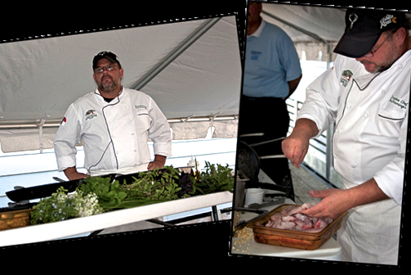Chefs from two of Hatteras Island’s most popular restaurants will square off in a seafood cooking competition at 3 p.m. on Saturday, Sept. 21 at Day at the Docks in Hatteras village.
Steve Whitley and Ben McNamara from Rusty’s Surf and Turf in Buxton will meet Michael Jenkins and Adam Tyndall from The Mad Crabber Restaurant in Avon in the challenge.
The teams will have one hour to prepare dishes using a local seafood ingredient that will be revealed only when the competition starts.
Dishes will be judged on taste, originality, presentation and use of the entire animal.
Whitley started working in kitchens when he was a teenager and went on to attend the culinary arts school at Johnson and Wales University. He says that the availability of the freshest seafood and surprise catches, along with fresh herbs and vegetables straight from the farmer’s market, helps distinguish locally owned restaurants from corporate competitors.
McNamara is the former owner and chef of Isabella’s in northeast Philadelphia. Fond of merging French- and Italian-based techniques with Asian, Spanish and other influences picked up over the course of a career in the kitchen, he says his overall philosophy is to create dishes that “I would enjoy eating.”
Jenkins is a 3rd-generation chef. His career has spanned more than twenty years, primarily in the Chattanooga, Tennessee area. He says the variety of fresh, local seafood available on the Outer Banks fuels his imagination and inspires creativity in the kitchen.
Tyndall studied culinary arts at Cape Fear Community College in Wilmington. He says his formal training built on a childhood appreciation for good food and the importance of understanding ingredients and how to blend flavors.
Debbie Hamrick, specialty crops director at the NC Farm Bureau and NC Catchboard member, Lorraine Eaton, food writer at The Virginian Pilot, and Oscar La Fuente, executive chef at The Carolina Club at the University of North Carolina-Chapel Hill, will judge the throwdown dishes.
Emcee for the event is Bob Barris, a real estate broker with Hatteras Realty who also teaches Carolina Coastal Cooking classes at the company’s Avon office and who once worked as a commercial fisherman.
Jeff Aiken, owner of Jeffrey’s Seafood in Hatteras, will provide the secret seafood ingredient and will join Barris on stage to talk about what it takes to get seafood from the water to the dinner plate.
The Conetoe Family Life Center in Edgecombe County will provide produce from its community garden. Students at the Center farm 17 acres and sell produce and honey at farmers’ markets and to grocery stores and restaurants. Income from the project goes into scholarship funds for the youth members.
Throwdown sponsors are NC Sea Grant and the Northwest Atlantic Marine Alliance.
For more information, visit the Seafood Throwdown at Day at the Docks Facebook page or thewww.dayatthedocks.org’> Day at the Docks website. (.

Comments
Join the discussion:
You must login to post a comment.
Not registered? Create an account.

